Co-Chair  Vernon Sykes, Representative  34th House District | 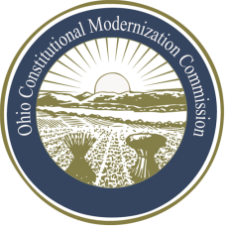 | Co-Chair  William G. Batchelder, Speaker  69th House District
Ohio Constitutional Modernization Commission

Finance, Taxation & Economic Development Roll Committee
Douglas Cole, Chair
Thursday, May 9, 2013

Douglas Cole, Chair | Karla Bell, Vice Chair
Chair Cole called the meeting of the Finance, Taxation, and Economic Development Roll Committee to order at 11:57a.m. A quorum was present.

The Chair welcomed the committee members and asked for ideas of how to proceed with this Committee. A suggestion was made to have a professional bond counsel present to the committee to help answer questions of the current functionality of bonds and also have an expert come and give a legal analysis of debt limits. The committee also indicated a desire for background information on taxes and economic development issues.

It was agreed upon that the committee would like individuals with expertise in the areas of bonds, taxes, and economic development to come in and present about their respective fields.

With no further business, the committee adjourned at 12:27p.m.

